# Design Documentation

# Home Dork

Revision History

|  |  |  |  |
| --- | --- | --- | --- |
| **Date** | **Version** | **Description** | **Author** |
| 2021-09-15 | 1.0 | Modifying Design documentation | Ali Habesh, Amr Al-shaaba, Stiv Abdulwahed, Hani Al-zir. |
| 2021-10-04 | 1.1 | Modified the images, changed POST to PUT, also images were not properly placed. | Ali Habesh, Amr Al-shaaba, Stiv Abdulwahed, Hani Al-zir. |
|  |  |  |  |
|  |  |  |  |

Design item List

|  |  |
| --- | --- |
| **Requirement Name** | **Priority** |
| D1. Log in system | Essential |
| D2. Scrolls & On/Off button (API get/post) | Essential |
|  | Desirable |
|  | Desirable |

Design Item Descriptions

### D1 – Log in

Log in system is used for user authentication to be able to access control of their home (smart house). The basic idea is to use the database with some form of security to identity the user before giving him access.

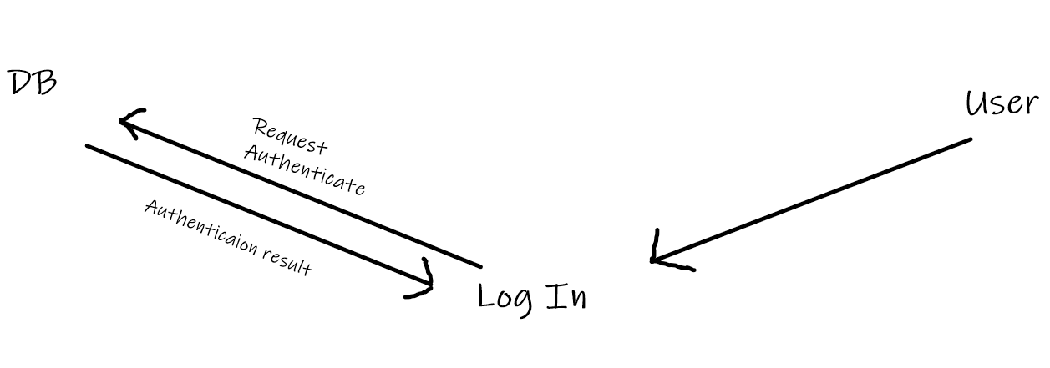

### D2 - Scrolls & On/Off button

The user should be able to communicate to his smart house through his private profile using features such as scrollers and buttons. The scroller could be used for a more specific input such as light sensitivity, while the button can be used as more off a binary input (on/off). The buttons will give information and receive information using API’s get/post methods, which essentially means the web/phone application will communicate with the server.

